**Geographical Scope for sales**

**The Major customers are:**

1. **National Pipe Company (NPC)**

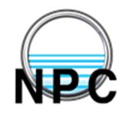

1. **The Egyptian Company for pre-stressed concrete (ECPC)**

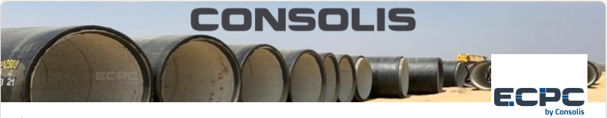

1. **Egyptian Company for Pipes and Cement Products**



1. **National authority for Tunnels (NAT)**

